IT 360 Cloud Integration | Week 3 | Team Lab 2 (Canvas 3.3, 40 points)

Lab 2: Docker and a Jenkins CI/CD Pipeline
Bonneville Brewing: a Jenkins job anyone can click that builds the menu-board image, tests it, tags it with the build number and pushes it with a password nobody can see
Version 2, November 2026. The pipeline in this guide was run end to end on November 8, 2026, including a real push to Docker Hub (every build green, the token in none of the logs). Your build numbers, times and image digests will differ; the shape of the output will not.
Duration: about 90 minutes in total (75 in class plus 15 to get ready)
Before class: 15 minutes (Docker Desktop test, Docker Hub account and access token, GitHub account, lab folder from the class repository). Do this before class if you can.
In class: 75 minutes of lab work in six parts (A 10, B 20, C 15, D 10, E 10, F 10). Part B is the longest because the Jenkins image builds once (3 to 6 minutes); do Part A on GitHub while it builds.
Instructor's timed run (November 8, 2026, real Docker Hub push): Jenkins sign-in page up 9 seconds after start, build #1 finished in 20 seconds, build #2 in 15 seconds; your first build can take a few minutes while Docker downloads NGINX.
Allow extra time if: Docker Desktop is not installed yet (15 to 30 minutes to install and restart) or your laptop cannot run Docker and you use a cloud VM instead.

The story
Bonneville Brewing shows its beer list on screens in four taprooms. The screens run a small web page packaged as a Docker image. Today one person builds that image on his laptop and pushes it to Docker Hub with his personal password, so nobody else can change the menu when he is away. The owner wants a Jenkins job anyone on staff can click. It must build the image, test it, tag it with the build number, and push it with a stored credential that never appears in a log.

What you will build
Part | What you do | Time
A. The code | Put the menu board (3 files) in a GitHub repository | 10 min
B. Jenkins | Run Jenkins in Docker and store your Docker Hub token in it | 20 min
C. The pipeline | Create the job, Build Now, read the console | 15 min
D. Change and repeat | Add a beer, build again, watch the tags | 10 min
E. Connectivity | Test every hop from browser to taproom screen | 10 min
F. Submit and clean up | Screenshots to Canvas, then remove the containers | 10 min
Total | Six parts in one lab session | about 75 min, plus 15 min before class

Team roles
Role | Owns
Jenkins administrator | Part B: runs Jenkins and creates the stored credential
Pipeline author | Parts A and C: the GitHub repository, the Jenkinsfile and the job
Registry owner | Part D: Docker Hub repository and the tags
Quality lead | Parts D and E: searches every log for the password and writes the one-line sign-off

Run Jenkins on one laptop and share that screen. Teammates follow along and take over their parts.

Before you start (15 minutes, ideally before class)
☐ Docker Desktop is installed and running (whale icon in the menu bar on Mac, in the system tray on Windows). Test it in a terminal (Mac: Terminal; Windows: PowerShell): docker run --rm hello-world must print Hello from Docker!.
☐ Docker Hub account (free) at https://hub.docker.com. Write your username in the table below.
☐ Docker Hub access token: your avatar (top right) > Account settings > Personal access tokens > Generate new token. Description jenkins-lab, access Read & Write, Generate. Copy the token into your password manager now; Docker Hub shows it only once. Never paste it into a file, a chat or a screenshot.
☐ GitHub account at https://github.com.
☐ The lab folder from the class repository https://github.com/isijackson/IT360-Fall-Labs-v2: click the green Code button, then Download ZIP, and unzip it. The folder you need is Week 3 labs/jenkins-docker-pipeline, which contains the folders jenkins and menu-board. (Git users: git clone https://github.com/isijackson/IT360-Fall-Labs-v2.git.)
☐ No laptop that can run Docker? Use a Vocareum AWS, Azure or Google Cloud VM with Docker installed; the commands are the same.
Item | Value in this guide | Yours
Docker Hub username | <user>
Docker Hub token | stored in Jenkins only | never write it here
GitHub repository | https://github.com/<github-user>/menu-board
Jenkins | http://localhost:8080, admin / admin | same
Credential ID | dockerhub-credentials (exact spelling) | same

Where you run things
Place | How to open it | What you do there
Terminal (Mac) or PowerShell (Windows) on your laptop | Part B Step 1 shows how to open it inside the `jenkins-docker-pipeline` folder | Every docker command: build Jenkins, start it, run the image
GitHub in your web browser | https://github.com | Part A (create menu-board, upload 3 files, edit line 4) and Part D Step 3 (add a beer)
Jenkins in your web browser | http://localhost:8080 (sign in as admin / admin) | Part B Step 5 (the credential), Part C (the job, Build Now, Console Output), Part D Step 1
Docker Hub in your web browser | https://hub.docker.com | Before class (the access token) and Part D Step 2 (the tags)
Cloud Shell | Not used in this lab | Nothing: Lab 2 runs on your laptop's Docker

Every command block below starts with an orange ▶ Run in: line that tells you exactly where to run it.
How to read this guide
Click: numbered steps in a web page (GitHub, Jenkins, Docker Hub). Screenshots show the same clicks with red numbers.
Type: commands for your terminal. Each command is one line, so it works the same in Mac Terminal and Windows PowerShell.
You should see: green boxes with the real output from the November 8 run.
If not: yellow boxes with the fix.
Replace anything in angle brackets, like <user>, including the brackets.

Part A. Put the code on GitHub (Pipeline author, 10 min)
Goal: a GitHub repository Jenkins can read. It holds three files: index.html (the menu), Dockerfile (how to build the image) and Jenkinsfile (the pipeline).
- On GitHub, click + (top right) > New repository. Name: menu-board. Choose Public. Click Create repository.
- On the empty repository page, click uploading an existing file.
- Drag the three files from the menu-board folder of the class repository download into the page: index.html, Dockerfile, Jenkinsfile. Click Commit changes. (Upload only these three; your own repository must have them at the top level, so do not fork or upload the whole class repository.)
- Click Jenkinsfile, then the pencil icon (Edit).
- On line 4, replace YOUR_DOCKERHUB_USER with your Docker Hub username. Keep the quotes and the /menu-board part.
- Click Commit changes twice.
You should see
Three files in the repository, and line 4 of the Jenkinsfile reading (with your username):
IMAGE_NAME = "${env.IMAGE_NAME ?: '<user>/menu-board'}"
The Jenkinsfile names the credential by its ID (dockerhub-credentials) and never contains a password. Anyone can read it safely.

The pipeline has four stages. Read them once now so the console output in Part C makes sense:
Stage | What it does
Checkout | Downloads your repository
Build | docker build: makes the image and tags it with the build number, for example <user>/menu-board:1
Smoke test | Starts the new image as a temporary container and checks the page answers with HTTP 200. If it does not, the pipeline stops and nothing is pushed.
Push | Logs in to Docker Hub with the stored credential and pushes two tags: the build number and latest

Part B. Run Jenkins and store the credential (Jenkins administrator, 20 min)
Goal: Jenkins running at http://localhost:8080, able to use Docker, holding your Docker Hub token as a credential.
Step 1. Open a terminal in the lab folder
Mac: open Terminal, type cd (with a space), drag the jenkins-docker-pipeline folder into the window, press Enter. Windows: in File Explorer open the jenkins-docker-pipeline folder, click the address bar, type powershell, press Enter. Check you are in the right place:
▶ Run in: Terminal (Mac) or PowerShell (Windows) on your laptop, after moving into the jenkins-docker-pipeline folder as described above.
ls
You should see
jenkins and menu-board in the list (plus a few other files).

Step 2. Build the Jenkins image (one time, 3 to 6 minutes)
▶ Run in: Terminal (Mac) or PowerShell (Windows) on your laptop, inside the jenkins-docker-pipeline folder (the one that contains jenkins and menu-board).
docker build -t it360-jenkins jenkins
This image is the official Jenkins plus the Docker command and the Docker Pipeline plugin. It also skips the setup wizard and creates the sign-in admin / admin for you.
You should see (last lines)
=> naming to docker.io/library/it360-jenkins
No red ERROR lines. A second run is much faster because Docker reuses the layers.

Step 3. Create the lab network and start Jenkins
▶ Run in: Terminal (Mac) or PowerShell (Windows) on your laptop, the same window and folder as Step 2. Paste one line at a time.
docker network create brewlab
docker run -d --name jenkins --network brewlab -e SMOKE_NET=brewlab -p 8080:8080 -v /var/run/docker.sock:/var/run/docker.sock it360-jenkins
docker exec -u root jenkins chmod 666 /var/run/docker.sock
Verify Jenkins is running and can use Docker (same terminal)
docker ps --filter name=^jenkins$ --format "{{.Names}} {{.Status}} {{.Ports}}"
docker exec jenkins docker version --format "docker CLI {{.Client.Version}}, server {{.Server.Version}}"
You should see (versions may differ):
jenkins Up 20 seconds 0.0.0.0:8080->8080/tcp, [::]:8080->8080/tcp
docker CLI 27.5.1, server 28.4.0
If the second command says permission denied, run the chmod line again. If docker ps shows nothing, run docker logs jenkins and read the last lines.

Why these options matter
-v /var/run/docker.sock:... lets Jenkins use your laptop's Docker to build images.
Because of that, the smoke-test container Jenkins starts is a neighbour of Jenkins, not inside it. --network brewlab and -e SMOKE_NET=brewlab let Jenkins reach that neighbour by name. Leave them out and the smoke test fails with "connection refused".
The chmod line lets the Jenkins user talk to Docker. Without it builds fail with permission denied ... docker.sock.

Step 4. Sign in
- Wait about a minute, then open http://localhost:8080 in your browser.
- Sign in as admin, password admin. (This is a lab-only account on your laptop.)
You should see
The Jenkins dashboard: Welcome to Jenkins!, with New Item and Manage Jenkins on the left.

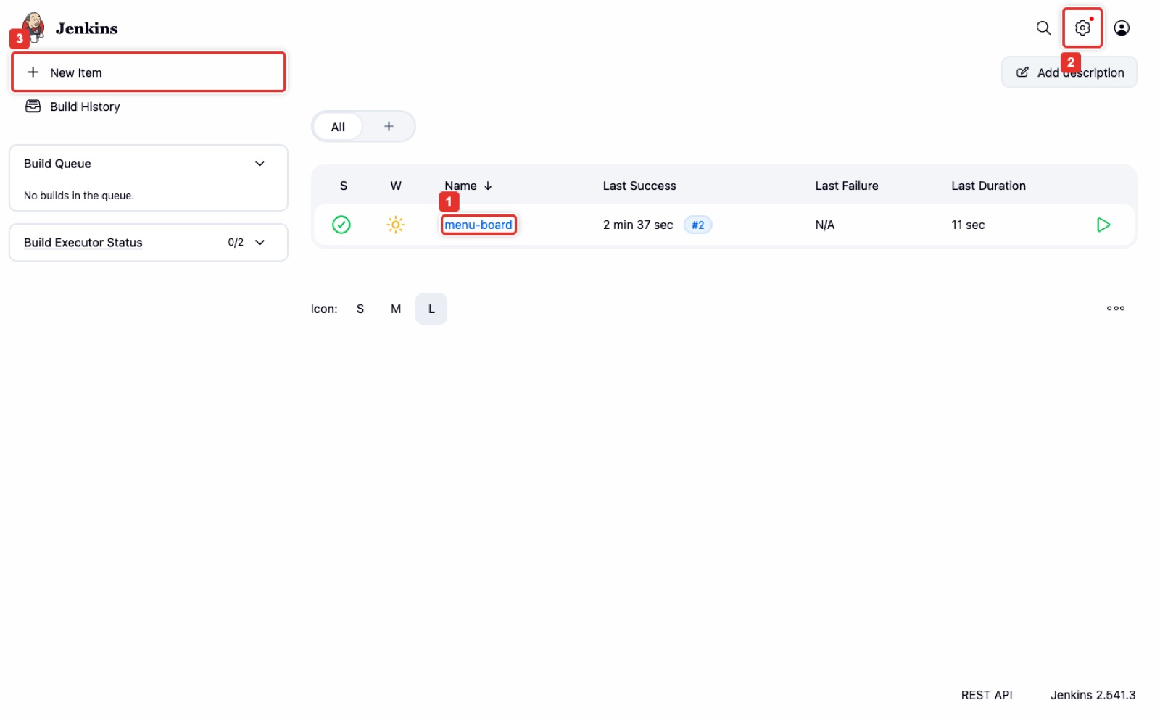
Figure 1. The Jenkins dashboard. Yours has no menu-board job yet; you create it in Part C.
Step 5. Store your Docker Hub token as a credential
- Click Manage Jenkins > Credentials.
- Under Stores scoped to Jenkins, click System, then Global credentials (unrestricted).
- Click + Add Credentials.
- Kind: Username with password. Scope: Global.
- Username: your Docker Hub username. Password: your Docker Hub access token (not your Docker Hub password).
- ID: dockerhub-credentials (exactly this; the Jenkinsfile looks for it). Description: Docker Hub.
- Click Create.
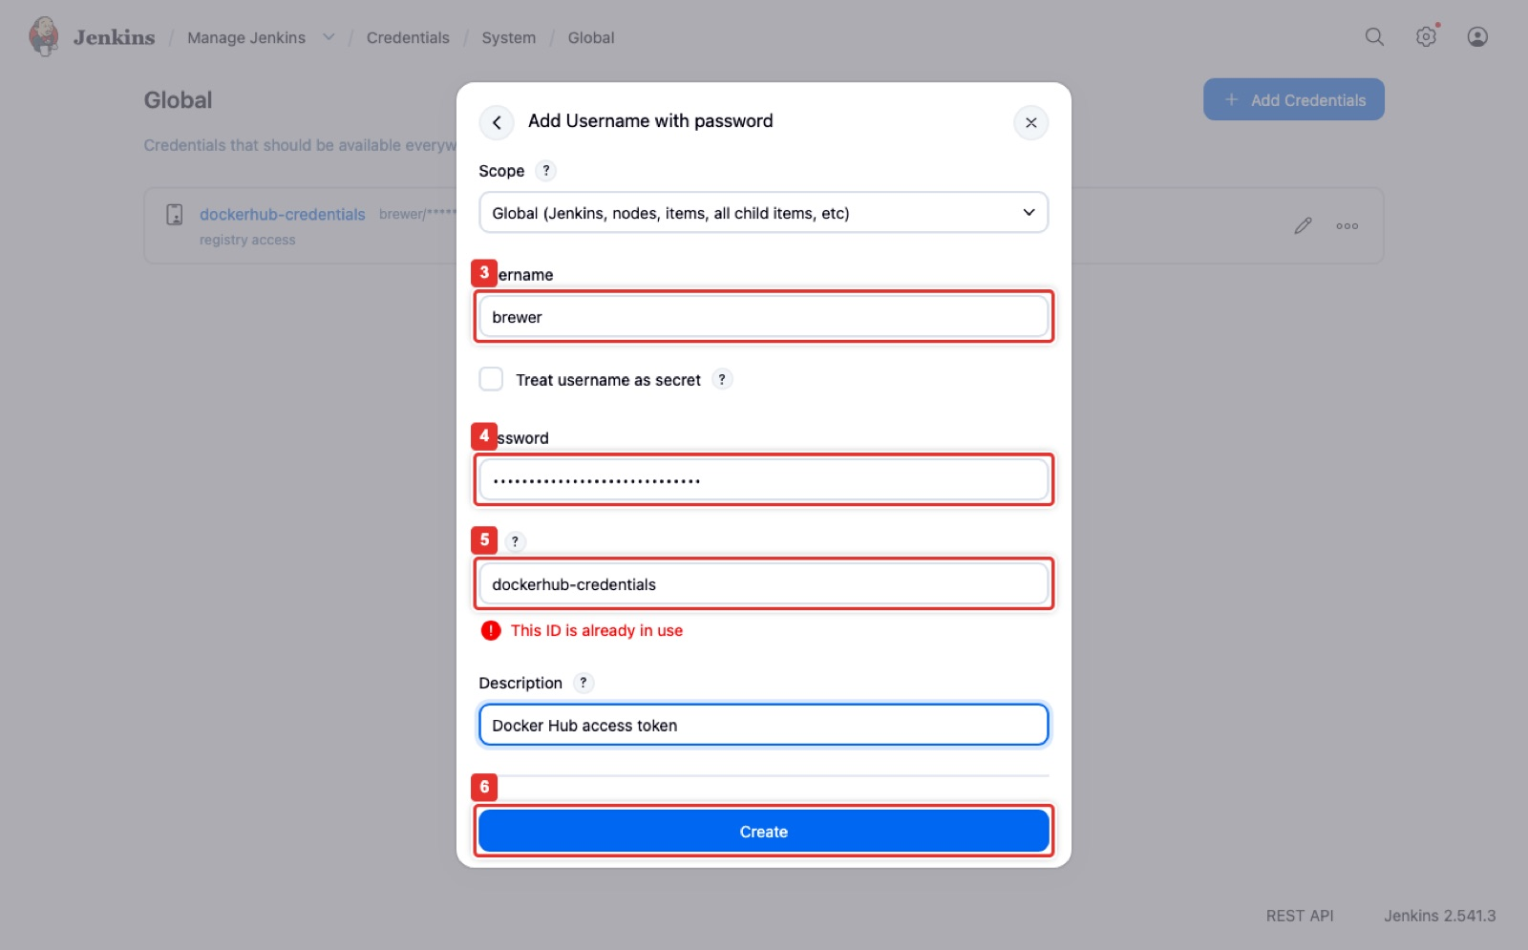
Figure 2. Add Credentials: Username with password, the token in Password, ID dockerhub-credentials.
You should see
The list shows dockerhub-credentials as <user>/******. The token is now stored encrypted, and Jenkins will never show it again, not even to you.

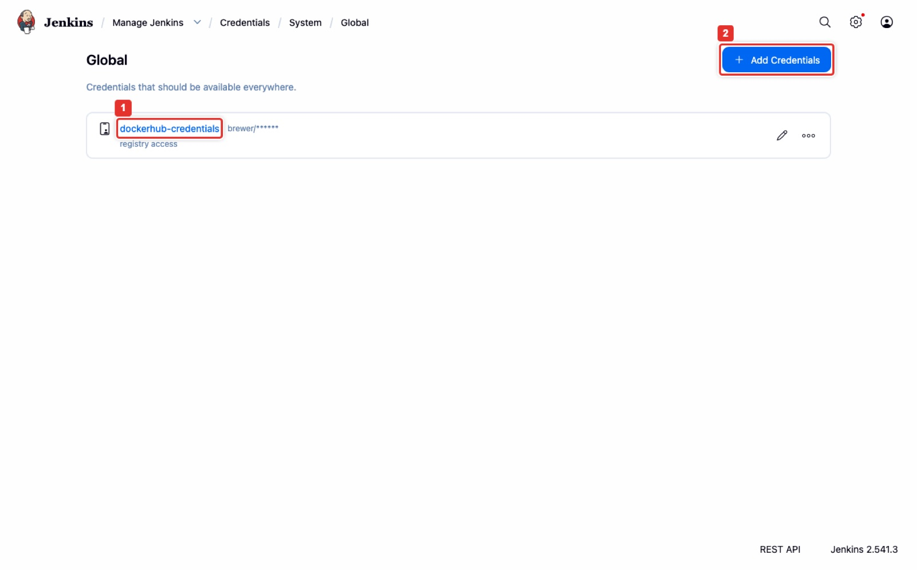
Figure 3. Global credentials: dockerhub-credentials listed with the secret hidden.
Checkpoint: where does the token live now, and who can read it?
Encrypted inside Jenkins. Only jobs that name the ID dockerhub-credentials can use it, and they never see it printed.

If not
port is already allocated on docker run: something else uses port 8080. Run docker rm -f jenkins, then the docker run line again with -p 8090:8080, and use http://localhost:8090 from now on.
Conflict. The container name "/jenkins" is already in use: an old Jenkins is there. docker rm -f jenkins, then run Step 3 again (skip network create if it says the network exists).
The page does not open: wait another minute; docker logs jenkins should end with Jenkins is fully up and running.

Part C. Create the pipeline and run it (Pipeline author, 15 min)
Goal: a job named menu-board that reads the Jenkinsfile from your GitHub repository, and a first green build.
- On the dashboard, click + New Item.
- Name: menu-board. Choose Pipeline. Click OK.
- Scroll to the Pipeline section. Definition: Pipeline script from SCM.
- SCM: Git. Repository URL: https://github.com/<github-user>/menu-board.git. Leave Credentials as none (the repository is public).
- Branch Specifier: change */master to */main.
- Script Path: Jenkinsfile (already filled in).
- Click Save.
- Click Build Now. Build #1 appears under Build History. Click #1, then Console Output.
Verify the job (Jenkins in your browser, after step 7)
The page heading reads menu-board with Build Now and Configure on the left. Click Configure and scroll to Pipeline: it still shows Pipeline script from SCM, your repository URL, */main and Jenkinsfile. If any value is empty, fix it and Save again before Build Now.

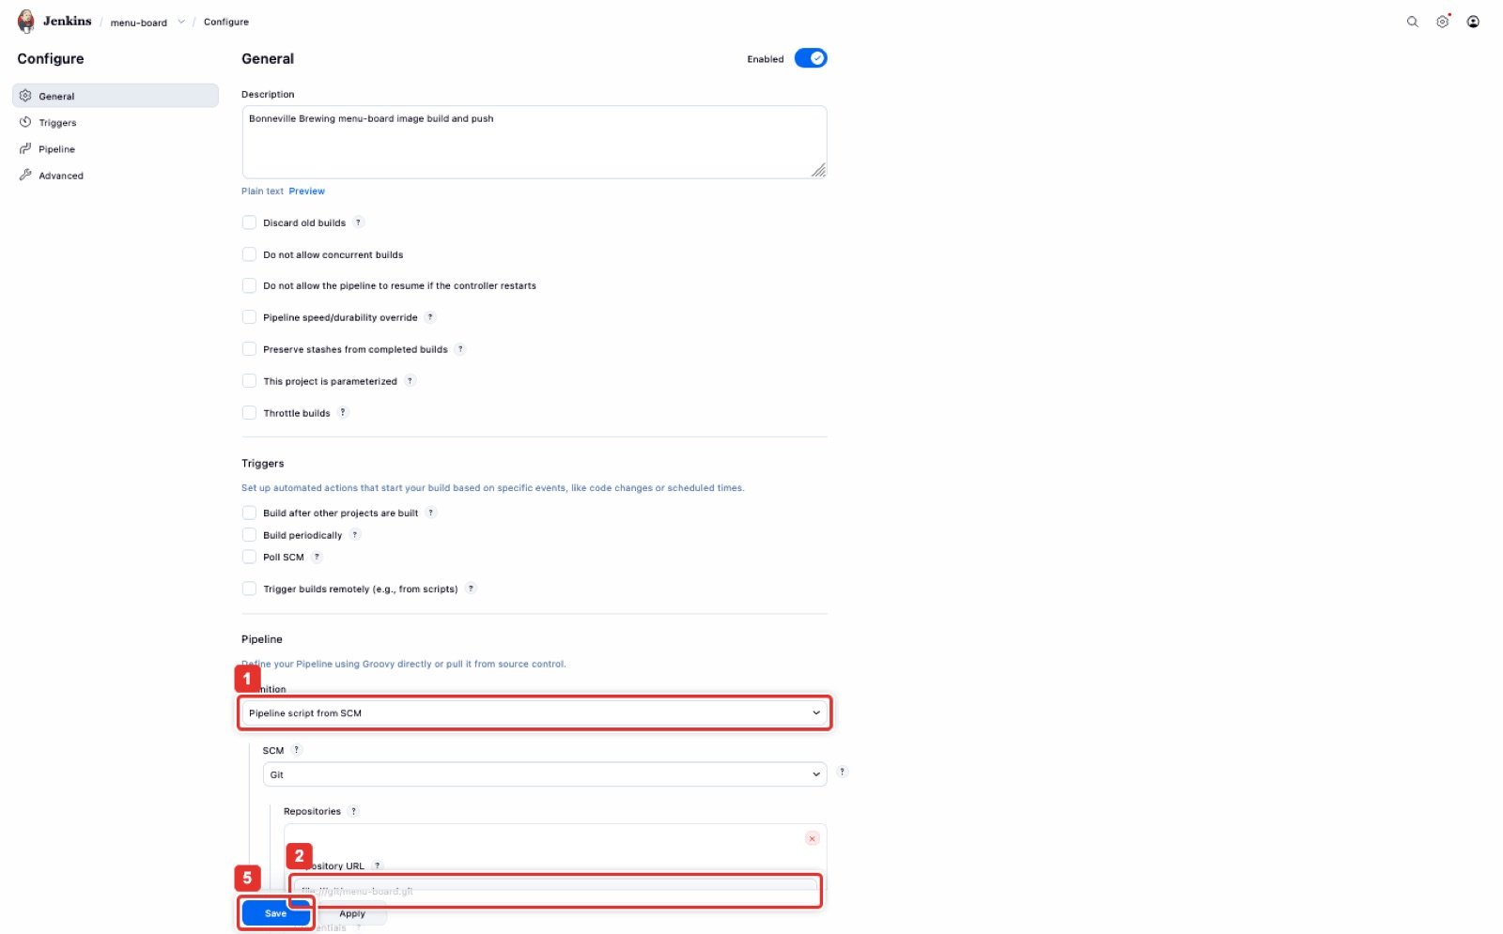
Figure 4. Configure > Pipeline: Pipeline script from SCM, Git, your repository URL, branch */main, Save.
You should see in Console Output (the important lines)
Checking out Revision ... (refs/remotes/origin/main)
+ docker build -t <user>/menu-board:1 .
HTTP 200
$ docker login -u <user> -p ******** https://index.docker.io/v1/
Login Succeeded
+ docker tag <user>/menu-board:1 index.docker.io/<user>/menu-board:1
+ docker push index.docker.io/<user>/menu-board:1
1: digest: sha256:02dd2bbc2049... size: 2196
+ docker push index.docker.io/<user>/menu-board:latest
Finished: SUCCESS
Two lines starting WARNING! Using --password via the CLI is insecure and WARNING! Your password will be stored unencrypted in .../menu-board@tmp/... are printed by Docker for every login from Jenkins. They are normal here: the console still shows only ********, and Jenkins deletes that temporary folder when the stage ends.
HTTP 200 is the smoke test passing. ******** is your token, masked. On the instructor's Docker Hub run (November 8) build #1 took 20 seconds and build #2 15 seconds; your first build can take a few minutes while Docker downloads NGINX. Take Screenshot 1: the Console Output with HTTP 200, the masked login and Finished: SUCCESS.

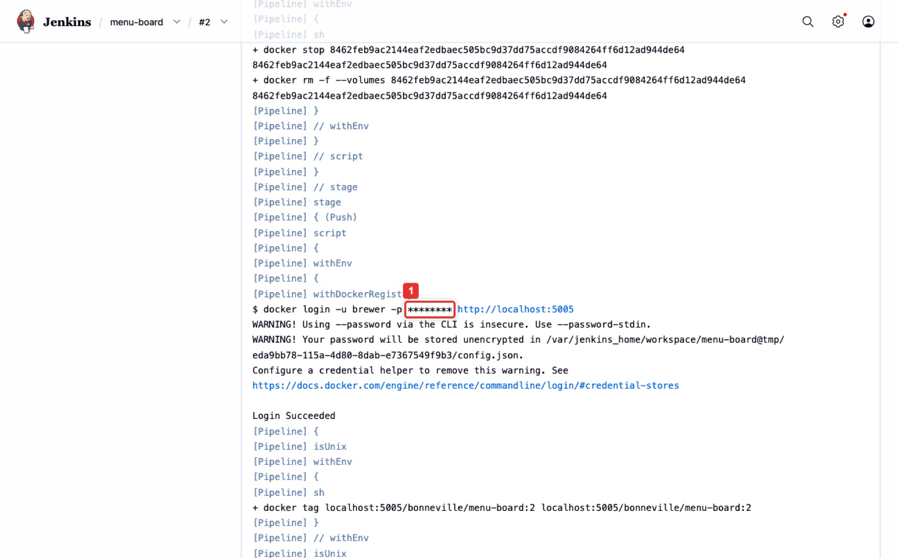
Figure 5. Console Output: docker login with the password printed as ********.
If not
Couldn't find any revision to build: the branch is wrong. Configure, Branch Specifier */main, Save, Build Now.
permission denied while trying to connect to the Docker daemon socket: run docker exec -u root jenkins chmod 666 /var/run/docker.sock, then Build Now.
Smoke test: curl: (7) Failed to connect: Jenkins was started without --network brewlab -e SMOKE_NET=brewlab. docker rm -f jenkins and redo Part B Step 3 to Step 5 (the credential must be added again).
unauthorized: incorrect username or password at Push: the credential holds your password instead of a token, or a typo. Manage Jenkins > Credentials > dockerhub-credentials > Update, paste the token again.
denied: requested access to the resource is denied at Push: line 4 of the Jenkinsfile does not match your Docker Hub username exactly.
Could not find credentials entry with ID 'dockerhub-credentials': the ID is spelled differently. Fix the ID, not the Jenkinsfile.

Part D. Prove it, change the menu, build again (Registry owner and Quality lead, 10 min)
Step 1. Check the secret is not in the log (Quality lead)
- Stay on build #1's Console Output.
- Press Ctrl+F (Mac: Cmd+F) and paste your token into the search box.
- The browser must find 0 matches. Then search for ********: you find it on the docker login line.
Checkpoint
If the token can be found anywhere in the log, the job fails the client's requirement. The quality lead writes one line for the submission: "I searched the console output of builds 1 and 2 for the token and found no matches."

Step 2. Check the tags on Docker Hub (Registry owner)
- Open https://hub.docker.com, then Repositories > menu-board > Tags.
- You see tags 1 and latest. Take Screenshot 2.
Docker Hub created the repository for you on the first push. Free accounts make it public, which is fine for a menu.
Step 3. Add a beer and build again (Pipeline author)
- On GitHub, open index.html and click the pencil icon.
- Just before </ul>, add a beer, for example <li>Timp Trail IPA 6.5%</li>.
- Click Commit changes twice.
- In Jenkins, open menu-board and click Build Now. Build #2 runs.
You should see
Build #2: HTTP 200, the masked login, pushes of :2 and :latest, Finished: SUCCESS.
Docker Hub Tags: 2, latest and 1. Tag latest now has the same digest and push time as 2: it moved. Take Screenshot 3.

Step 4. Run the image like a taproom screen would
▶ Run in: Terminal (Mac) or PowerShell (Windows) on your laptop. Any folder. Then open http://localhost:8081 in your web browser.
docker run --rm -p 8081:80 <user>/menu-board:2
Open http://localhost:8081: the menu shows your new beer. Port 8081 because Jenkins already uses 8080. Stop it with Ctrl+C in the terminal. Then run tag 1 the same way: the new beer is gone. That is a rollback.
Verify (your browser)
http://localhost:8081 with tag 2 lists three beers, the last one Timp Trail IPA 6.5% (or the beer you added).
With tag 1 it lists only Wasatch Wheat 5.2% and Antelope Island Amber 5.8%.
Mac users can also check in Terminal: curl -s http://localhost:8081 | grep -o "<li>[^<]*</li>"

Checkpoint: a taproom says the board broke after today's build. Which tag do they go back to?
The previous number, tag 1. Every build left a numbered tag, so you always know exactly what to go back to. latest is a pointer that moves; numbers never move.

Part E. Test connectivity end to end (10 min)
Every hop in this lab is a network connection. Check each one and compare with the instructor's November 8 result.
Hop | How to check | Instructor result (Nov 8)
Your browser to Jenkins | Open http://localhost:8080 | Sign-in page, HTTP 200
Jenkins to GitHub | Console: Checking out Revision ... | Checkout of main OK
Jenkins to the smoke-test container | Console: Smoke test stage | HTTP 200
Jenkins (Docker) to Docker Hub | Console: Login Succeeded, two pushes | Login with -p ********, two tags
Secret never in the log | Ctrl+F your token in Console Output | 0 matches (checked on builds 1 and 2 with a real Docker Hub token)
Registry: latest moved | Docker Hub Tags: latest and newest number | Same digest
Taproom screen to the image | docker run -p 8081:80 <user>/menu-board:2 | Menu with the new beer, HTTP 200

Stuck? Ask an AI assistant the right way
Copy the failing stage's lines from Console Output into GitHub Copilot Chat, ChatGPT/Codex or Gemini and ask what caused it. Never paste your token. Check any fix it suggests against the "If not" boxes in this guide before you apply it.

Part F. Submit, then clean up (10 min)

What to submit in Canvas 3.3
☐ Screenshot 1: build #1 Console Output showing HTTP 200, the masked docker login line and Finished: SUCCESS.
☐ Screenshot 2: Docker Hub Tags showing 1 and latest.
☐ Screenshot 3: Docker Hub Tags showing 1, 2 and latest after the second build.
☐ The Jenkinsfile (your copy, with your username on line 4).
☐ A 2 to 3 sentence summary that names who did what.
☐ The quality lead's one-line confirmation that the token appears nowhere in the logs.

Clean up
▶ Run in: Terminal (Mac) or PowerShell (Windows) on your laptop. Any folder.
docker rm -f jenkins
docker network rm brewlab
docker rmi it360-jenkins <user>/menu-board:1 <user>/menu-board:2 <user>/menu-board:latest
docker ps -a
You should see
docker ps -a no longer lists jenkins. Docker Hub's free tier costs nothing, so you can keep the repository. If you used a cloud VM, delete it.
If you think your token was ever exposed (pasted somewhere, visible in a screenshot), delete it in Docker Hub > Personal access tokens and create a new one. That is exactly what a security team would do.

Plan B: no Docker Hub account or GitHub access
On a Mac (or Windows with WSL), the lab folder has a script that runs the whole pipeline against a private registry container on your laptop, with no accounts. It creates Jenkins, the credential, the job, two builds, and checks the logs for the password:
▶ Run in: Terminal on a Mac, or WSL Ubuntu on Windows (not PowerShell), inside the jenkins-docker-pipeline folder.
bash scripts/deploy-lab3-2.sh
bash scripts/rollback-lab3-2.sh -y
Use it to see a working pipeline, then do the lab with Docker Hub for your submission. Ask the instructor before submitting a Plan B run.

Troubleshooting at a glance
You see | Do this
docker: command not found or Cannot connect to the Docker daemon | Start Docker Desktop and wait until it says Running.
permission denied ... docker.sock in a build | docker exec -u root jenkins chmod 666 /var/run/docker.sock
Smoke test: connection refused | Restart Jenkins with --network brewlab -e SMOKE_NET=brewlab (Part B Step 3).
unauthorized at Push | Put the access token, not your password, in the credential.
denied: requested access to the resource is denied | Jenkinsfile line 4 must be <your Docker Hub user>/menu-board.
Couldn't find any revision to build | Branch Specifier */main.
Port 8080 or 8081 already in use | Use another host port: -p 8090:8080 or -p 8082:80.
Jenkins gone after a laptop restart | docker start jenkins, wait a minute, sign in again.

Words to know
Word | Meaning in this lab
Image | A packaged app (here: NGINX plus the menu page) that runs the same on any machine.
Container | A running copy of an image.
Registry | Where images are stored and shared. Docker Hub is a registry.
Tag | A label on an image version: 1, 2, latest.
Pipeline | The automated steps from code to a pushed image, written in the Jenkinsfile.
Credential | A secret stored in Jenkins and used by ID, never shown.
Smoke test | A quick check that the new image starts and answers before it is pushed.

